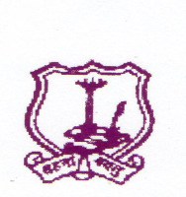
The Umrer Academy of Arts & Sciences
MAHILA KALA MAHAVIDYALAYA, UMRED
Academic Calendar for College
Session 2022-2023
1 | College session starts | 23/06/2022
2 | Yoga Day | 21/06/2022
3 | Staff Meeting | 25/06/2022
4 | College Admission Start | 01/07/2022
5 | College classes starts | 01/08/2022
6 | NSS Inauguration Program | 08/08/2022
7 | Dr. Rangnathan Birth Anniversary | 12/08/2022
8 | Independence Day | 15/08/2022
9 | Tree Plantation | 20/08/2022
10 | National Sports Day | 29/08/2022
11 | Teachers Day | 05/08/2022
12 | Guest lecture on Environment | 20/08/2022
13 | N.S.S. Foundation Day | 24/09/2022
14 | D. Laxminarayan Day | 30/09/2022
15 | Mahatma Gandhi Birth Anniversary | 02/10/2022
16 | Alumani Students Meeting | 07/10/2022
17 | Parents Meeting | 08/10/2022
18 | First Term exam | 8/10/2022 to 18/10/2022
19 | Staff Meeting | 10/10/2022
20 | Diwali Vacation | 20/10/2022 to 29/10/2022
21 | Winter Vacation | 19/11/2022 to 07/12/2022
22 | RTMNU Winter Exam Start | 21/11/2022
23 | Constitutional Day | 26/11/2022
24 | Dr. B.R. Ambedkar Death anniversary | 06/12/2022
25 | College Second session start | 08/12/2022
26 | Staff Meeting | 10/12/2022
27 | Guest lecture on the memory of late M. Badiye and M. Joshi | 15/12/2022
28 | N.S.S. special camp | 20/12/2022 to 27/12/2022
29 | Savitribai Fuley Birth anniversary | 03/01/2023
30 | Swami Vivekanand Birth Anniversary | 12/01/2023
31 | Shardotsav (Cultural Program) | 03/01/2023 to 04/01/2023
32 | Parents Counseling Meeting | 18/01/2023
33 | Educational tour | 20/01/2023
34 | Republic Day | 26/01/2023
35 | Alumani Meeting | 06/02/2023
36 | College Practice exam | 20/02/2023 to 28/02/2023
37 | Women’s Day | 08/03/2023
38 | Farewell Program | 15/03/2023
39 | RTMNU Summer Exam Start | 22/03/2023
40 | Dr. Ambedkar Birth Anniversary | 14/04/2023
41 | Staff Meeting | 20/04/2023
42 | Maharashtra Din | 01/05/2023
43 | Summer Vacation | 01/05/2023 to 15/06/2023

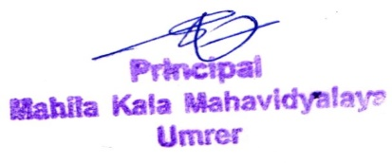
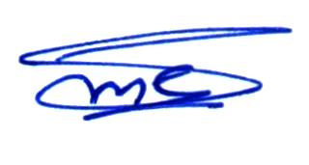

IQAC Coordinator Principal
Mahila Kala Mahavidyalaya, Umred

