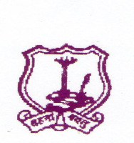
The Umrer Academy of Arts & Sciences
MAHILA KALA MAHAVIDYALAYA, UMRED
-------------------------------------------------------------------
Academic Calendar 2018-2019
- College session starts :- 15/06/2018
- Yoga Day :- 21/06/2018
- College classes starts :- 02/07/2018
- Tree Plantation :- 07/07/2018
- Lokmanya Tilak Death Anniversary :- 01/08/2018
& Annabhau Sathe Birth Anniversary
- N.S.S. Inauguration :- 06/08/2018
- Dr. Rangnathan Birth Anniversary :- 12/08/2018
- Independence Day :- 15/08/2018
- Lecture on Environment :- 23/08/2018
- Sports Day :- 29/08/2018
- Teacher’s Day :- 05/09/2018
- Class Representative appointment :- 20/09/2018
- N.S.S. Foundation Day :- 25/09/2018
- University Representative appointment :- 28/09/2018
- D. Laxminarayan Day :- 30/09/2018
- Mahatma Gandhi &
Lal Bahadur Shashtri Birth Anniversary :- 02/10/2018
- Ex-Students Meeting :- 03/10/2018
- First unit test :- 25 to 29 sept. 2018
- Parents Meeting :- 16/10/2018
- First sessional exam :- 3 oct. to 15 oct.2018
- Diwali Vacation :- 18/10/2018 to 17/11/2018
- Constitutional Day :- 26/11/2018
- Mahaparinirvan Din :- 06/12/2018
- Second session start :- 19/11/2018
- N.S.S. special camp :- 20/12/2018 to 26/12/2018
- Second unit test :- 25/01/2019 to 31/01/2019
- Shardotsav :- 01/01/2019 to 03/01/2019
- Savitribai Fuley Birth Anniversary :- 03/01/2019
- Swami Vivekanand Birth Anniversary :- 12/01/2019
- Educational tour :- 20/01/2019
- Republic Day :- 26/01/2019
- Second sessional exam :- 15/02/2019
- Women’s Day :- 08/03/2019
- Send off :- 20/03/2019
- Dr. Ambedkar Birth Anniversary :- 14/04/2019
- Second session Ends :- 30/04/2019
- Maharashtra Din :- 01/05/2019

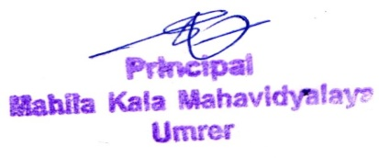

Principal

