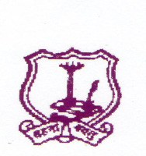
The Umrer Academy of Arts & Sciences
MAHILA KALA MAHAVIDYALAYA, UMRED
-------------------------------------------------------------------
Academic Calendar for College
Session 2021-2022
- Admission College reopens after summer vacation – 16/6/2021
Admission Arts - 17/6/2021
Last date of admission - 20/09/2021 as per University Rules
Teaching commence from - 2/8/2020
Introductory meet of students - Third week of August
Staff Meeting - 1 st Day of the Session
- Last Day of the Session
- 2 nd Day of the second Session
- Last Day of the second Session
2) National Days –
Independence Day
- Republic Day
- Maharashtra Day
3) Day Observed
International Yoga Day - 21/06/2021
Teachers Day - 5/9/2021
National Sports Day - 29/08/2021
D. Laxminarayan Day - 30/09/2021
NSS Foundation Day - 24/09/2021
Tree Plantation - 17/7/2021
Swachchata Abhiyan - 14/8/2021
Vachan Prerana Day - 02/10/2021
Gandhi & Lal Bahadur Shastri Jayanti - 02/10/2021
Constitutional Day - 26/11/2021
Dr. Ambedkar Mahaparinirvan Day - 06/12/2021
Savitribai Fulye Jayanti - 03/01/2022
Yuva Day - 12/01/2022
Voters Day - 25/01/2022
Marathi bhasha day - 27/02/2022
International Women’s Day - 08/03/2022
MahaTma Fulye Jayanti - 11/04/2022
Dr. B. R. Ambedkar Jayanti - 14/04/2022
4) College Annual Day - First week April
5) Guest Lecture - Last Week of February
6) NSS Special Camp - March second week
7) College Unit Test
First Session - 20 to 25 September 2021
Second Unit Test - 20 to 25 October 2021
Second Session - 7 to 13 March 2022
Second Unit Test - 15 to 21 April 2022
8) Examination –
1 st semester 01/12/2021
2 nd semester 09/05/2022
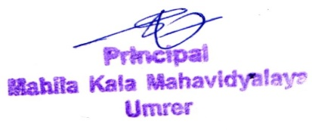
SPECIAL INSTRUCTTONS :- 1) All efforts should be made to achieve more than 180 teaching days in Annual pattern and 90 days in Semester pattern.
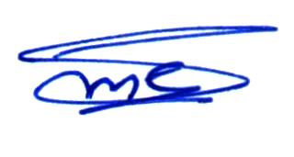

IQAC Coordinator Principal
Mahila Kala Mahavidyalaya, Umred

