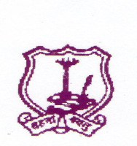
The Umrer Academy of Arts & Sciences
MAHILA KALA MAHAVIDYALAYA, UMRED
-------------------------------------------------------------------
Academic Calendar 2020-2021
- Admission
College reopens after summer vacation – 16/6/2020
Admission Arts - 20/6/2020
Last date of admission - 15/09/2020 as per University
Rules
Teaching commence from - 2/8/2020
Introductory meet of students - Third week of August
Staff Meeting - 1st Day of the Session
- Last Day of the Session
- 2nd Day of the second Session
- Last Day of the second Session
- National Days - Independence Day
- Republic Day
- Maharashtra Day
- Day Observed
International Yoga Day - 21/06/2020
Teachers Day - 5/9/2020
National Sports Day - 29/08/2020
D. Laxminarayan Day - 30/09/2020
NSS Foundation Day - 24/09/2020
Tree Plantation - 17/7/2020
Swachchata Abhiyan - 14/8/2020
Vachan Prerana Day - 02/10/2020
Gandhi & Lal Bahadur Shastri Jayanti - 02/10/2020
Constitutional Day - 26/11/2020
Dr. Ambedkar Mahaparinirvan Day - 06/12/2020
Savitribai Fulye Jayanti - 03/01/2021
Yuva Day - 12/01/2021
Voters Day - 25/01/2021
Marathi bhasha day - 27/02/2021
International Women’s Day - 08/03/2021
MahaTma Fulye Jayanti - 11/04/2021
Dr. B. R. Ambedkar Jayanti - 14/04/2021
- College Annual Day - First week of February
- Guest Lecture - Last Week of January
- NSS Special Camp - January second week
- College Unit Test
First Session - 25 to 30 September 2020
Second Unit Test - 15 to 22 October 2020
Second Session - 7 to 13 February 2021
Second Unit Test - 15 to 21 April 2021
- Examination - 1st semester 17/12/2020
2nd semester 22/05/2021
SPECIAL INSTRUCTTONS :-
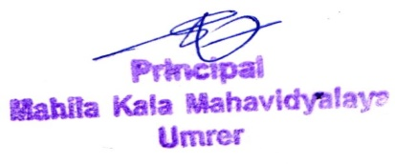
1) All efforts should be made to achieve more than 180 teaching days in Annual pattern and90 days in Semester pattern.

Principal

