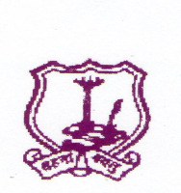
The Umrer Academy of Arts & Sciences
MAHILA KALA MAHAVIDYALAYA, UMRED
------------------------------------------------------------------- Academic Calendar 2019-2020
- Admission
College reopens after summer vacation – 16/6/2019
Admission Arts - 17/6/2019
Last date of admission - 05/09/2019 as per University
Rules
Teaching commence from - 2/7/2019
Introductory meet of students - Second week of August
Staff Meeting - 1st Day of the Session
- Last Day of the Session
- 2nd Day of the second Session
- Last Day of the second Session
National Days - Independence Day
- Republic Day
- Maharashtra Day
Day Observed
International Yoga Day - 21/06/2019
Teachers Day - 5/9/2019
National Sports Day - 29/08/2019
D. Laxminarayan Day - 30/09/2019
NSS Foundation Day - 24/09/2019
Tree Plantation - 17/7/2019
Swachchata Abhiyan - 14/8/2019
Vachan Prerana Day - 02/10/2019
Gandhi & Lal Bahadur Shastri Jayanti - 02/10/2019
Constitutional Day - 26/11/2019
Dr. Ambedkar Mahaparinirvan Day - 06/12/2019
Savitribai Fulye Jayanti - 03/01/2020
Yuva Day - 12/01/2020
Voters Day - 25/01/2020
Marathi bhasha day - 27/02/2020
International Women’s Day - 08/03/2020
MahaTma Fulye Jayanti - 11/04/2020
Dr. B. R. Ambedkar Jayanti - 14/04/2020
College Annual Day - First week February
Guest Lecture - Last Week of January
NSS Special Camp - January second week
College Unit Test
First Session - 10 to 15 September 2019
Second Unit Test - 9 to 18 October 2019
Second Session - 6 to 13 February 2020
Second Unit Test - 15 to 21 April 2020
Examination - 1st semester 27/11/2019
2nd semester 15/03/2020
SPECIAL INSTRUCTTONS :-
- All efforts should be made to achieve more than 180 teaching days in Annual pattern and90 days in Semester pattern.
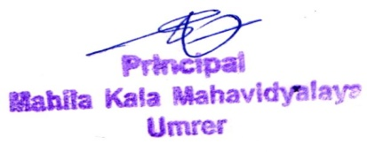

Principal

